**Mohammed Mahin Ibnay Mamun - 346584**

**Task 3 – Optimizing content, format, and features**

How have I improved search rankings?

The only way I can improve my search rankings on social media is by uploading posts. Therefor to reach my goal of earning search rankings I will need to post content on my social media platforms. Posting more content on social media gives me a greater chance of reaching searches, this is because for my audience, they will find it much difficult to find one specific video or post. On my social media platform, if I create more than one post, it puts me at a greater advantage. To create more traffic, I will have to make more than one post which I have done. If I successfully manage to create traffic on my platforms, then I will be able to get more views on my online website. Getting more views on my website is important because it leads to a greater chance of sales. I did this in more than one way. Below are headings with explanation of how I did this:

* **Posting Giveaways:**

Advantages and disadvantages of posting giveaways

Advantages:

1) A fantastic way to interact with your audience and get their attention.

2) A terrific way to gain a larger audience.

3) A wonderful way to make your customers happy. Especially if they win the giveaway which leads them to gaining a free product of their choice.

Disadvantages:

1) lose out on a sale causing your business to drop.

2) May have some upset customers.

On both of my social media platforms I have uploaded content which is announcing giveaways. This giveaway links to my Trainer company. For this giveaway, the winner will be able to select any product from my store and I will be giving it away to them for free. You may think this is a loss in my business. However, I have added requirements in this giveaway to help me gain traffic. Creating a giveaway is a wonderful way to get your audience to interact with your business. The requirements to enter this giveaway will be provided in the screenshot below. To enter you will need to: To enter you will need to: follow my profile, like my recent post, share this post on your story and finally tag 3 people in the comment section. Overall, this is a brilliant way to bring in a larger audience. The image below shows how it will look.

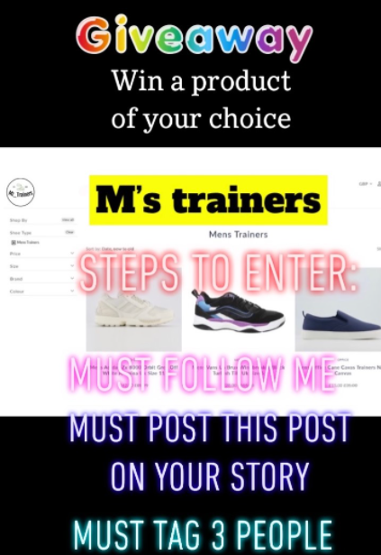

I have posted these in both image and video styles. For example, I have created an image post on Facebook announcing a giveaway. In contrast I created a video on tiktok which also announces the same giveaway. I decided to post on both social media platforms because it will give me more traffic compared to only posting on one platform. I will supply screenshots below so you can see what these looks like. For example, here is what the thumbnail for the tiktok post looks like.

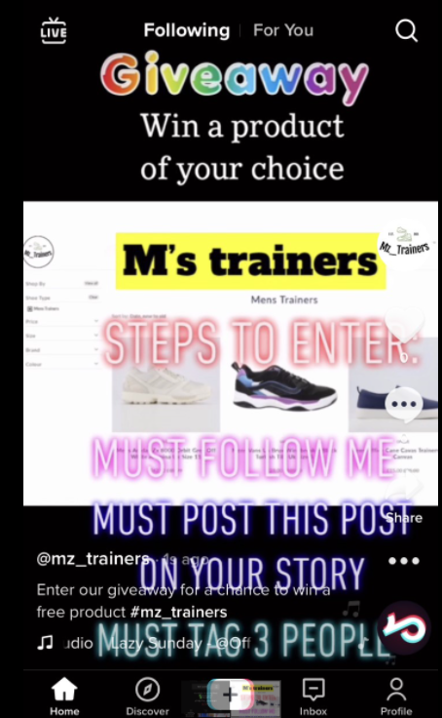

Above is a screenshot of what the viewers will see when they click on my video from my trainer company profile. They may also find this on their home page via the following or the For You tab labelled at the top of the screen.

Below is another image which looks quite like the asset above. However, this is the view of the end user once they click on my account. Aswell as being able to see my recent upload, they can also see my previous ones Aswell. Here is what it looks like.

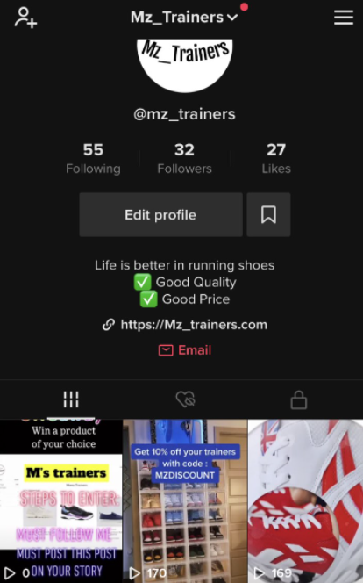

* **Posting images:**

Advantages and disadvantages of posting images.

Advantage:

1) Reach out to a larger audience.

2) More connection with new people.

3) Great way to advertise and promote your brand.

Disadvantages:

1) You may receive negative feedback.

2) You must wait to see the results

3) You can receive lots of copyright messages from others if your work has not been created by yourself.

If your company is selling a product, it is particularly important to include images on your social media platforms. This is mainly because your audience would want to see what the product, they are buying looks like. The best way to improve search rankings on social media platforms such as: Instagram, Facebook and Twitter are by creating a post which includes text Aswell as an image. Here is a post which I have recently created on Facebook. The post below is a prime example of what I have just mentioned above. As you can see, I have added an image Aswell as text. This feature is possible on all social media platforms, but they may be laid out differently. For example, as shown in my screenshot below the text appears above the image which contrasts to Instagram. Overall, it does not put you at any disadvantage because it still provides both features of an image and text. I may have been at a bigger advantage if I used keywords or hashtags in this text.

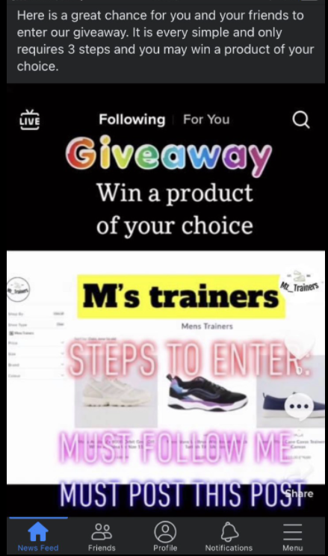

* **Keywords:**

**Advantages and disadvantages**

**Advantages:**

1) Niche and competitive targeting.

2) Topic cultivation also makes it easier to find a topic.

**Disadvantages:**

1) keyword stuffing. Keyword stuffing is when you fill the whole text with keywords to increase search. Viewers often dislike this.

2) Favoring search engine and tags over users.

I have managed to create traffic through the technique of keywords. One of the greatest ways I have improved my search ranking with keywords is by using hashtags. Using hashtags is a major way of using keywords. The hashtag is also visible to anyone, and they can also use the same hashtags as me.

Improvements based on my review plan.

**Social media policy:**

I have read over my reviewing plan and the feedback I received was you have created a professional and truly clear social media policy.it is noticeably clear because I have used subheading to label out each area of the document. This was the feedback strength. However, as an opportunity to improve my social media policy, I have been asked to write less and keep it short as possible. Acting upon this feedback, I have rewritten over my review plan and removed some text which is extra. Another opportunity to improve which I received from my reviewer was to explain how my company will act upon these social media policies. In my social media policy document, I have listed in bold 10 examples, but I did not manage to mention how my trainer company will follow these policies. Therefore, to improve my social media policy I will work on this opportunity and adjust my social media policy.

**Types of content I will be posting:**

I have created an action plan which clearly shows when I will be working on which platform and what time Aswell as which goal, I am aiming to reach within this task. For feedback on my review plan, I was told to make my notes more specific. By working on improving my action plan overall my company will be more successful, and I will not fall behind on any tasks if I stick to the action plan.

**Interacting with online community/audience:**

Reading over my feedback on my viewing plan, my reviewer wrote ‘you have identified the target audience for your business, briefly outlining.’ Reading this feedback, I can acknowledge the fact that I have pointed out my target audience, but it has briefly been explained.

**Keywords:**

Advantages and disadvantages of using keywords:

Advantages:

1) track popular trends.

2) Reaches out to potential audience/targets your audience. It is much easier to find your target audience by using keywords.

3) increases organic reach to your company.

Disadvantages:

Once again, I received feedback from the same reviewer based on my keyword section in my social media policy. He said ‘Yes, you have used keywords to attract an audience, these include ‘male,’ ‘female’ ‘trainers. More keywords could be used such as ‘unisex’ if they support that shoes type. I and the reviewer can clearly see I have completed the task by adding keywords but thankfully he has given me feedback on how I can adapt to my work and make it better. Making it better would mean I have improved my search ranking, which is the goal of this task, so therefore I will work on this and update my keyword section by using their advice.

How did I plan the use of social media while also demonstrating individual responsibility, creativity, and self-management?

**Business requirement report:**

Avoiding controversy by creating a social media policy:

A controversy is a **‘disagreement, often a public one, that involves different ideas or opinions about something’** to avoid this when creating social media, you must avoid giving your opinion on other companies or other posts on social media. When I tried creating my social media accounts, I had a problem. However, I knew I had to avoid controversy therefore I did not question it and I had to think of another solution. I also had to be creative about this situation and self-manage it myself. The situation which occurred was the fact that my company name was already taken by someone else. Therefor I had no choice but to be creative and manage it by myself and think of another. For example, here is what it looked like when I tried to create an account on titkok.

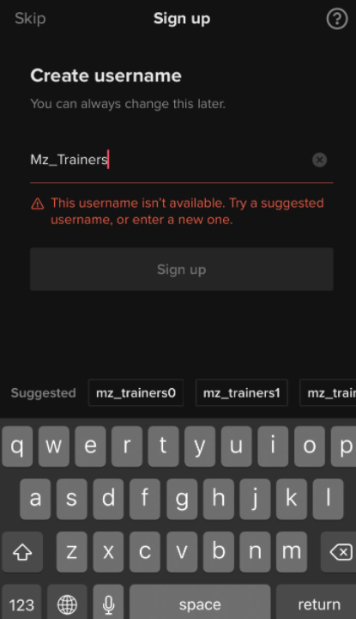

As you can see from the screenshot which I have provided above, my business name was not available. This meant someone has already created an account with this existing username. In this case I had 2 options. I could have just simply chosen to use one of the suggested usernames which is also visible on the screenshot above. However, I decided to be created about it and I managed to change it ever so slightly.

Planning and managing my time by making an action plan:

When making my action plan, I had to be creative about it and think of different ideas which I can do each day. It would be boring to be completing the same task each day. I also tried pushing myself by adding extra tasks and notes. You can see this on my action plan under the extra and notes.

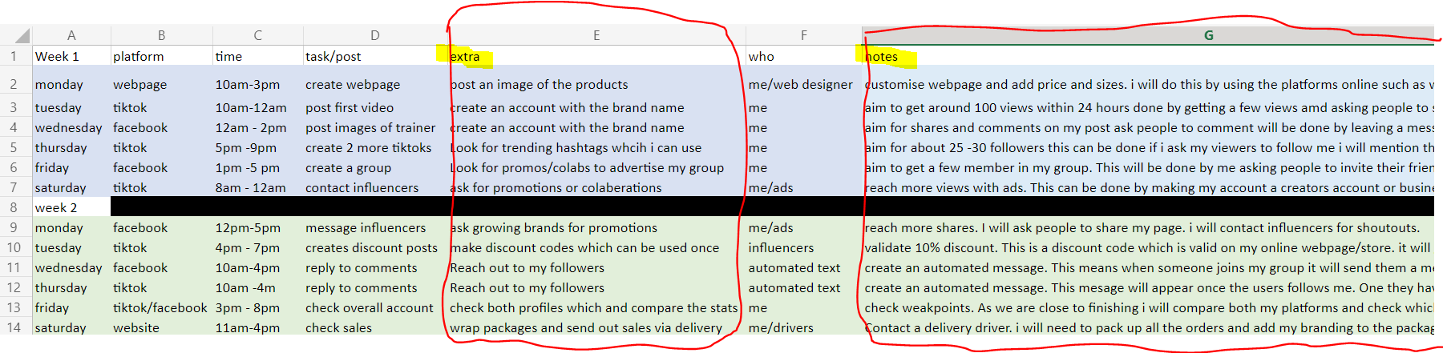

I also had to be very self-managing in this task on the time stamps I had chosen. This is because I had to select the most appropriate times for myself to complete this task.

Creativity and content I posted:

When it came to creating posts, I did this by creating images for my trainer Facebook page and I also created videos for my companies Tiktok profile. During this task I had to be creative and make my videos stand out from others. I also had to act upon and follow social media policies especially when it came to areas such as using keywords and appropriate content and I had to make sure no personal information was exposed. Overall, I was highly creative in this task because I used desktop apps such as photoshop to edit my images and I also used editing apps such as iMovie to edit my clips and images to make sure it is not like others or else It would be classed as copywrite.